Societal Implications of Crowdfunding Success for Korean and Chinese Films
on Sexual Slavery - Through <Spirit’s Homecoming> in Korea and <22> in China –

Jiang Danwei, Chang Eun jin

Dept. of Global Cultural Contents,Hankuk University of Foreign Studies Graduate School,
Dept. of Visual Contents , Graduate School of Dongseo University BK21+ Agency
Seoul & Busan, Republic of Korea
jiangdanwei90@163.com
Greenmumu@dongseo.ac.kr

Abstract

In October, UNESCO’s International Advisory Committee added Joseon dynasty’s missions to Japan, co-submitted by Korea and Japan, to its Memory of the World register. However, the records of the so-called comfort women, the sexual slavery victims of the Japanese imperial army during the Second World War, were denied a place on the register due to Japan’s resistance. The issue of sexual slavery, a historical fact from a half a century ago, remains a sensitive and complex problem for Korea, China and Japan; entangled with political interests of the three nations, resolution may not come so easily.
This research studies a Korean film and a Chinese documentary which addressed sexual slavery to explore contemporary perspectives on the issue along with a discussion of their aesthetic difference. In addition, in relation to how the films were disseminated to the public, the societal implications of crowdfunding, a rising production method for visual contents in the era of SNS, will be explored.

Keywords; Films on sexual slavery, crowdfunding, <Spirit’s Homecoming>, documentary <22>,

Ⅰ . Introduction :
Sexual Slavery Victims Enter the Public Sphere of History; <Spirit’s Homecoming> and <22>
The so-called comfort women were the sexual slaves who were forced to serve the Japanese military during the Japanese military invasion over Asia. Numerous records on the Nanking Massacre and atrocities in Korea show the Japanese army engaging in invasion, pillage, and killings in China and Korea during the Second World War. Women not only from China and Korea but also from the Philippines, Malaysia, Vietnam and Russia were forced into sexual slavery; but the Japanese government is yet to issue a sincere apology or acknowledgement of its wrongdoing. Whereas there have been consistent calls for national compensation and accountability in Korea, China have remained relatively quiet on the issue; however, with the recent production of documentary films on the issue, it would appear that China too is turning to take a more proactive stance on its history.
<Spirit’s Homecoming> took 14 years in the making from the moment the director Jungrae Cho found an inspiration in <Young Ladies Burning> by Ms. Ilchool Kang, a former sexual slave, while he was still at university. <22> from China is a sequel to the director Gwe Ke’s first work <32>; the number of surviving former sexual slaves has fallen from 32 to 22

Table 1. <Spirit’s Homecoming> & <22>
Category | <Spirit’s Homecoming>, Korea | <22>,  China
Genre | Low-budget  Independent Film | Documentary film
Director | Jungrae Cho | Gwe Ke (郭柯 )
Box office Attendance | 3.59 million | 15 million
Production Costs | 2.5 billion KRW | 0.4 billion KRW
Profit (Estimated) | 12 billion KRW | 15 billion KRW
Crowdfunding Revenue | 1.2 billion KRW | 0.17 billion KRW
Number of Crowdfunders | 75,000 | 30,000
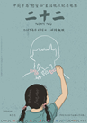

fig 1. movie Poster <Spirit’s Home comming>, <22>

This research examines the social functions are roles of films on sexual slavery as a ‘public sphere experience’ described by Jürgen Habermas. Expanding on the concept of ‘public sphere,’ Miriam Hansen’s notions of media and cultural studies will be studied to address the public sphere role of film industry through an examination of the crowdfunding successes of the two films.

II. How <Spirit’s Homecoming> and <22> addressed sexual slavery
A. <Spirit’s Homecoming>: Requiem for the Deceased

In <Spirit’s Homecoming>, the atrocities experienced by two girls in sexual slavery are represented in great detail. Considered uncomfortable by some spectators, a key scene is when sexual slaves are exploited in group by Japanese soldiers. The director takes a kite camera to pan from room to room to show Japanese soldiers waiting in line for their turn and each rooms where women are being taken advantage of; some question whether this scene was really necessary. The director Jungrae Cho has stated in media interviews that he wanted to emphasize how the collective system, the state, scarred the souls of individuals. <Spirit’s Homecoming> was also criticized on a scene where it was suggested that healing those scars could only be done with a shaman ritual through another female victim of sexual violence.

B. <22>: Why life is important – message of healing and restoration

Whereas <Spirit’s Homecoming> was based on testaments and in-depth interview with former sexual slaves to present a narrative which consoles those souls who have yet to return from foreign lands, China’s <22> shows the serenity of daily lives. The latter presents an old lady in her eighties doing household chores and living with a half-Japanese son whom she had during sexual slavery. The director Gwe Ke has mentioned in an interview that, because the director’s first film, <33>, had hurt many ladies who had been interviewed for the film, <22> was made with more restraints to give resonance through ordinary scenes. <Spirit’s Homecoming> based on historical facts and the documentary <22> showing the daily lives of surviving figures both show characters singing ‘arirang’ to move the viewers and console the surviving.

Table 2. Key Scenes from <Spirit’s Homecoming> and < 22>

 | Film Home coming | Documentary 22
Main Motif | 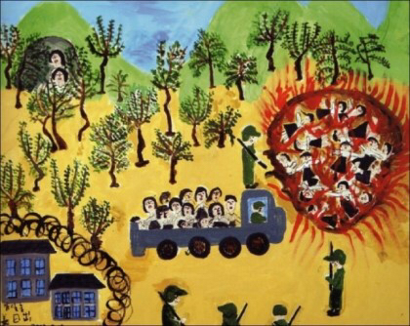 | 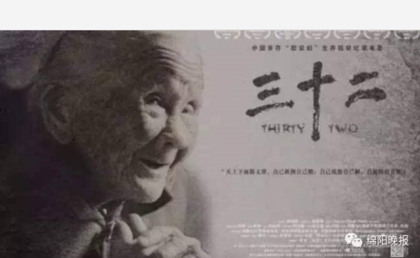
Main Motif | left : Young Ladies Burning  Right: 32 surviving former sexual slaves
Narrative | 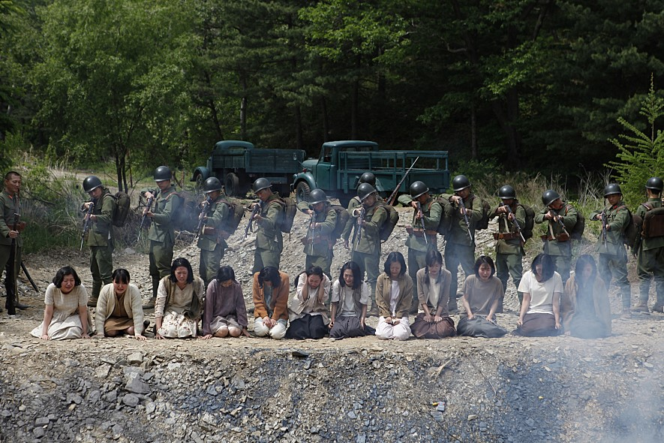 | 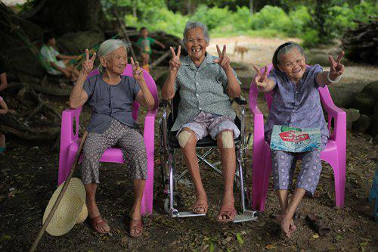
Narrative | <Spirit’s Homecoming>: Past–Pluperfect- Present,  Three layers of Present <22>: Testaments and daily lives of  survivors in the present narrative
Key Medium | 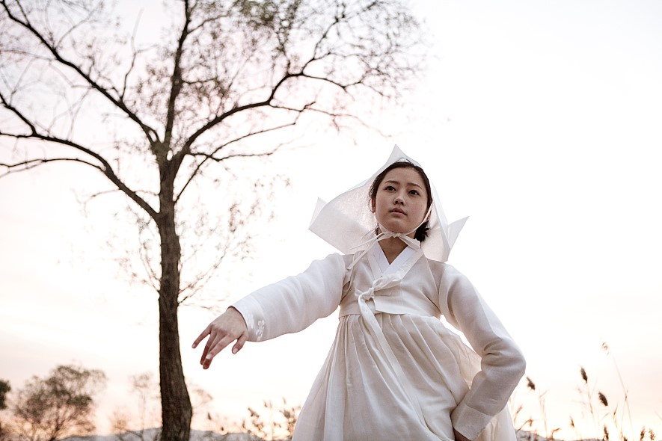 | 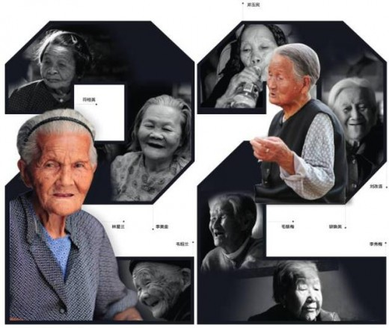
Key Medium | <Spirit’s Homecoming> : Eunkyung, a shaman, conducts  a consoling ritual to bring back the soul of the friend of  Younghee, a survivor, who finally frees herself from guilt  <22> : What consoles and heals the survivors is  ordinary life and communication with the director and crew

III. How <Spirit’s Homecoming> and <22> met the public: Crowdfunding
.
Even after the script was completed, the director struggled to finance <Spirit’s Homecoming>. Eventually, he turned to crowdfunding to raise 1.2 billion KRW to bridge the gap in project finance and finish the film. <Northern Limit Line> and <26 Years> had previously used the same method to finance their making. The director Gwe Ke of <22> had been inspired by <Spirit’s Homecoming> and decided to run a crowdfunding project in China during the final stage of making; the Korean production company which had worked for <22> also facilitated the crowdfunding project. As shown in [Fig. 3], three minutes of ending credit shows the list of all funders.



Fig. 2 Funder’s List in the ending credit in <22>

The same was the case for <Spirit’s Homecoming> where about half of production costs 1.2 billion KRW, which was raised through crowdfunding. The names of 77,270 citizen funders are shown for 10 minutes during the ending credit. This is in itself another moving scene in the film.

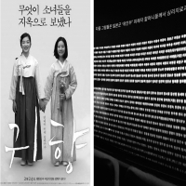

Fig. 3. Funder’s List in the ending credit in
<Spirit’s Homecoming>

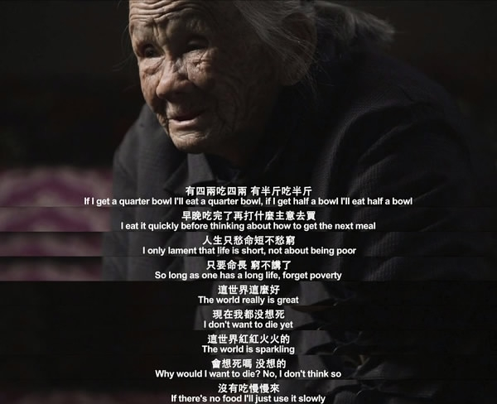
Fig. 4. The last wish of the old Japanese military sexual slavery survivor.

IV. Conclusion

Recently, films and documentaries based on historical facts are raising awareness of the long-forgotten reality. The history of sexual slavery, common to both Korea and China, has led to the film <Spirit’s Homecoming> and the documentary <22> to move tens of millions of people in the era of SNS.
<Spirit’s Homecoming> attracted 3.6 million box office viewers – the highest figure yet for a Korean film about sexual slavery. It also recorded the largest crowdfunding success in Korean cinema by raising 1.2 billion KRW. <22>’s crowdfunding success might have been moderate in comparison, but it generated a big social issue and added to the diversity of Chinese cinema where commercial films are in dominance. Future research should address the socio-cultural implications of crowdfunded films in Korea and China along with visual-aesthetic analysis so that the impact of historically-based visual content on the public in the era of SNS can be examined in depth.

References

[1] Kwen, Hyungjung, 「Cinematic Reconstruction of Sexual Slavers of Joseon 」,『Asian Cinema Study』 Vol. 9, 2. 2017.
[2] Kim, Insik, ,「Historical Fact and Cinematic Memory: The Issue of Cinematic Acceptance of History through <Schindler’s List>」, 『The Journal of Western History』, Vol. 29, 2002
[3] Joo, Yushin,「The New Challenge of Sexual Slavery Cinema and Historical Writing: on <Spirit’s Homecoming> and <Snowy Road>」,『The Journal of North-Eastern Asian Cultures』 Vol. 51,2017.
[4] Choi, Eunjoo,「Sexual Slave = Girl Narrative and Public Memory – on <Spirit’s Homecoming>」,The Korean Journal of Japanology, No.107,2016
[5] Cho, Geunha,「Polysemantic Interpretation of <Spirit’s Homecoming>」, Master’s Thesis, Yonsei University, 2017
[6]Guimei He. Memory of consumption and politics - "《Nanking！ Nanking！》《The Flowers Of War 》Cultural studies, 2013
[7] News survey < from 200000 to 22>
https://www.youtube.com/watch?v=KLZwEiJWFOk
[8] The regret of 《22》:
http://gy.qq.com/original/film/doc059.html
[9] < Spirit’s Homecomming> & Documentary Film<22>

